PRACTICAL-3

Practical name:- RSA encryption and decryption

RSA Encryption
DEFINITION:- RSA encryption is the process of converting plaintext into ciphertext using a public key. It ensures that only the intended recipient, who holds the private key, can decrypt the message.
RSA Decryption
DEFINITION:- RSA decryption is the process of reversing RSA encryption using the private key $d$and the modulus $n$, such that:
$$\text{Plaintext (}m\text{)}=c^{d}mod n$$
TOOLS:-Online website using.

STEP 1:- Go to the search bar and search RSA encryption and decryption.



STEP 2:- Open fist website Dev Glan RSA Encryption Decryption & key generator tool online.

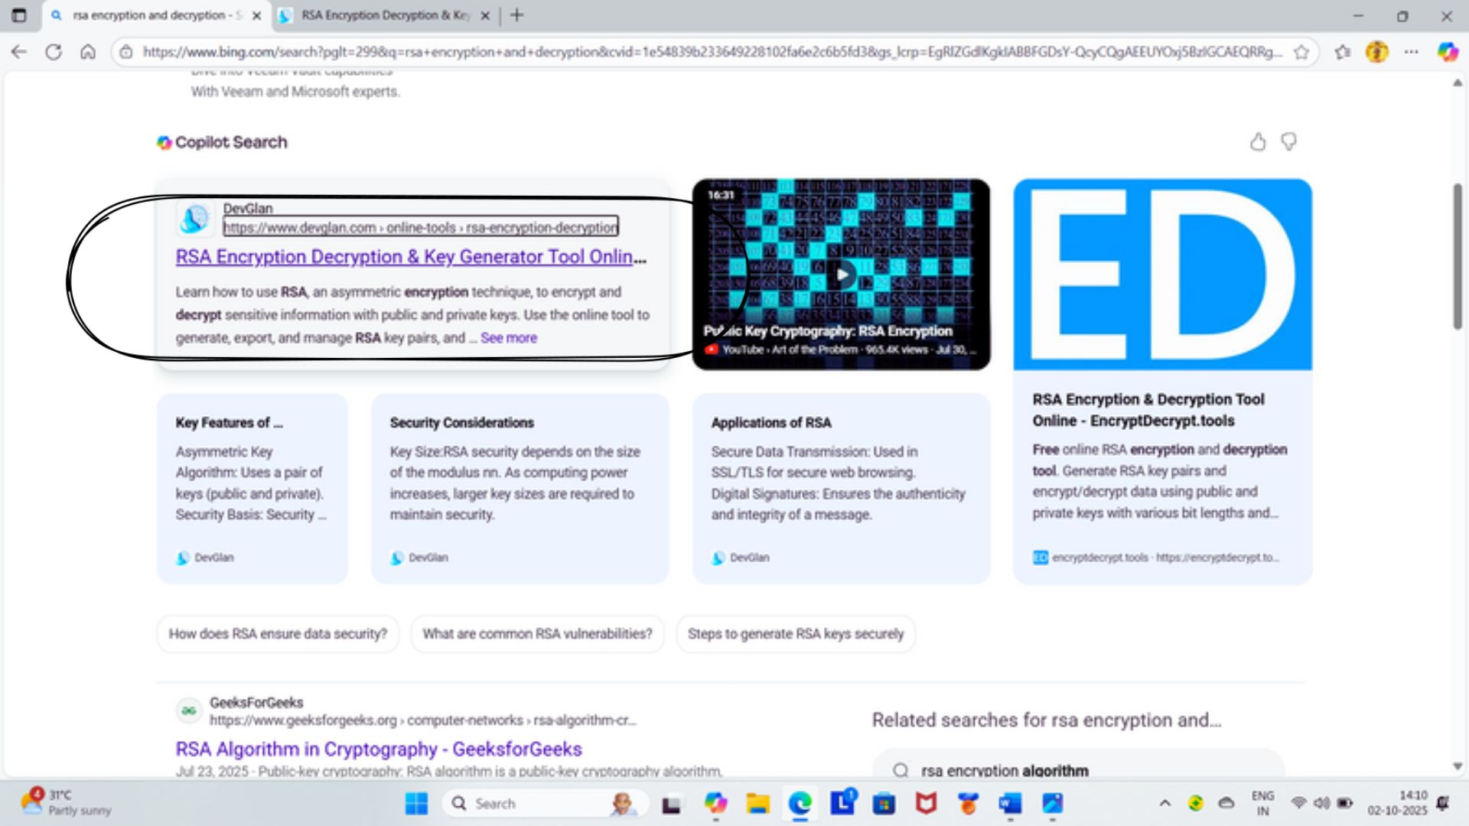
STEP 3:- Click on the generate RSA pair.

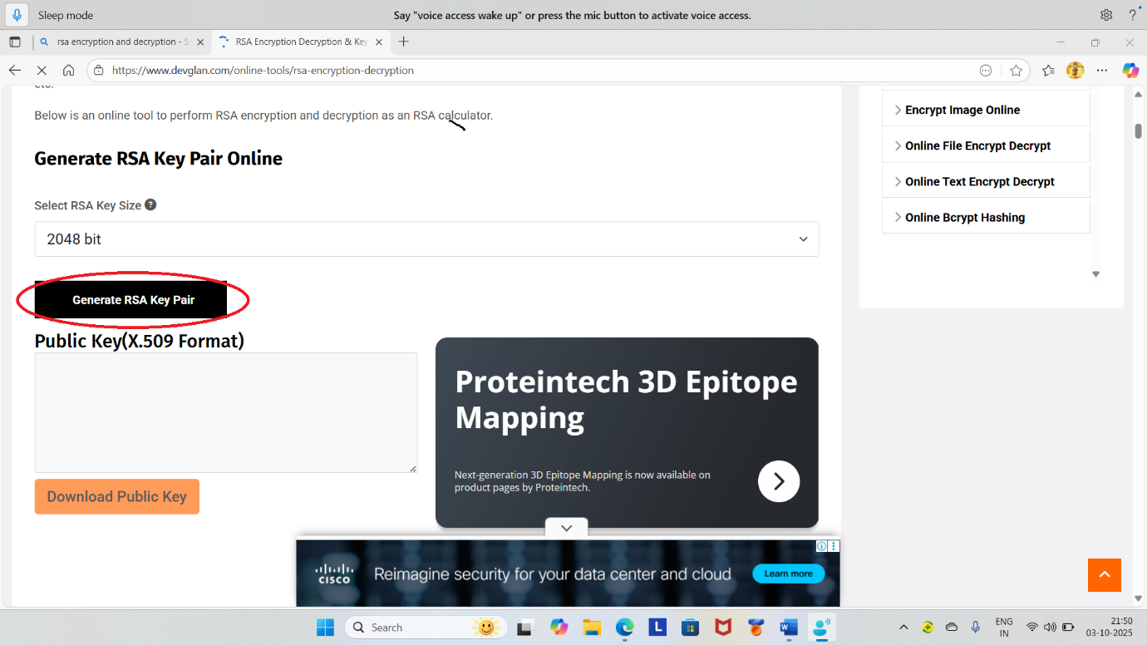
STEP 4:- Enter the text on RSA encryption Box then click on the Encrypt.

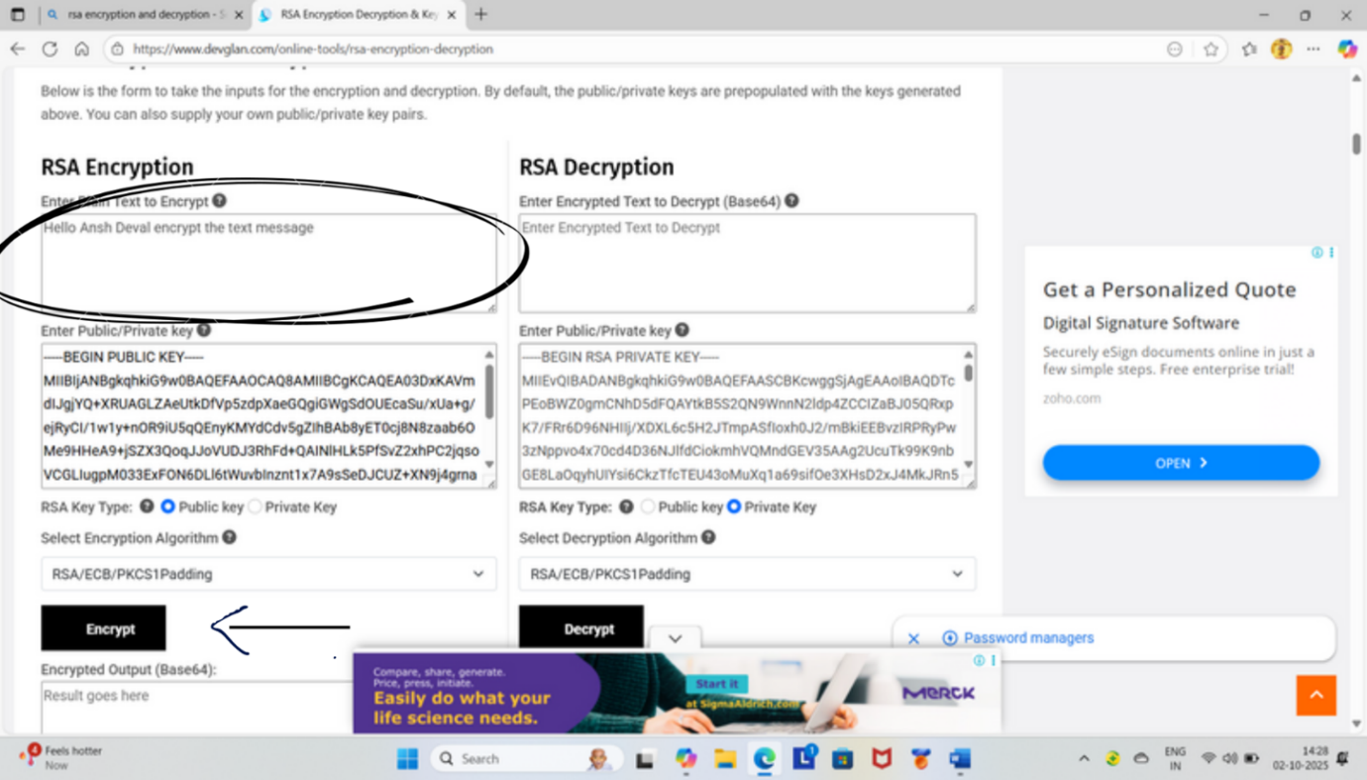

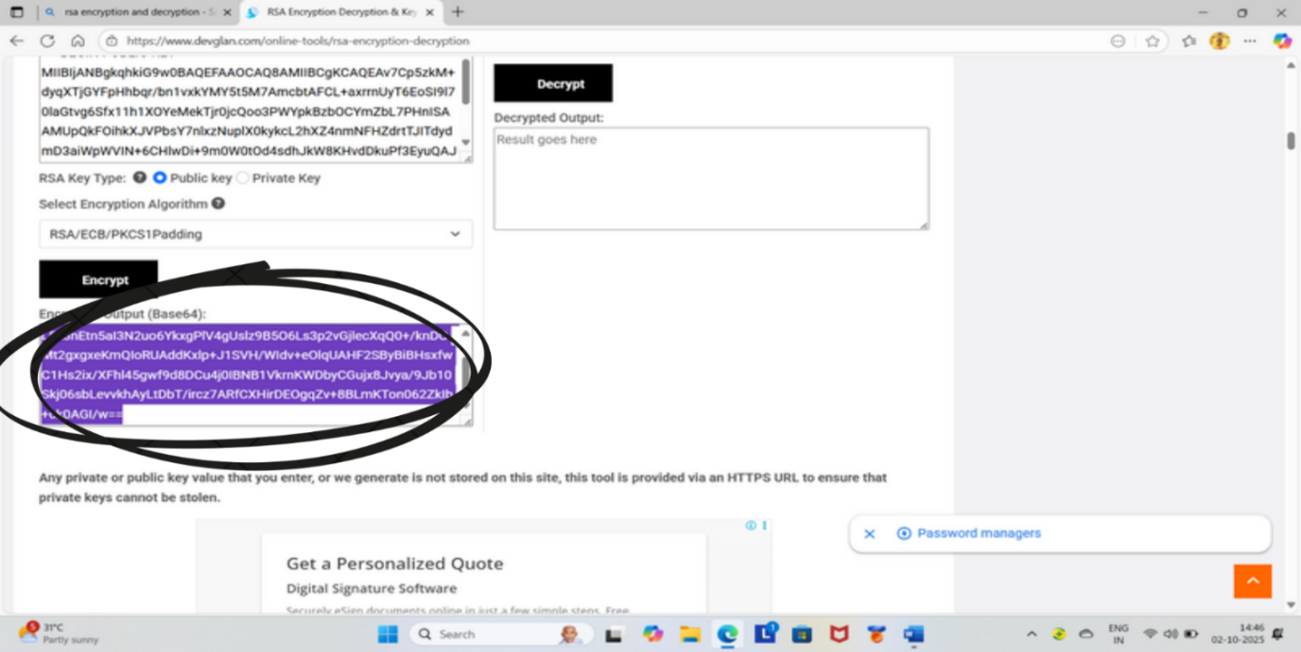
STEP 5 :- Copy the encrypted output and paste on the RSA Decryption Box.
STEP 6 :- Then click on the Decrypt . The you see the encrypted text in the decrypted output.

STEP 7:- I need a bit more context. There isn't a universal, in RSA unless you're following a specific numbered guide or textbook that labels the steps.

